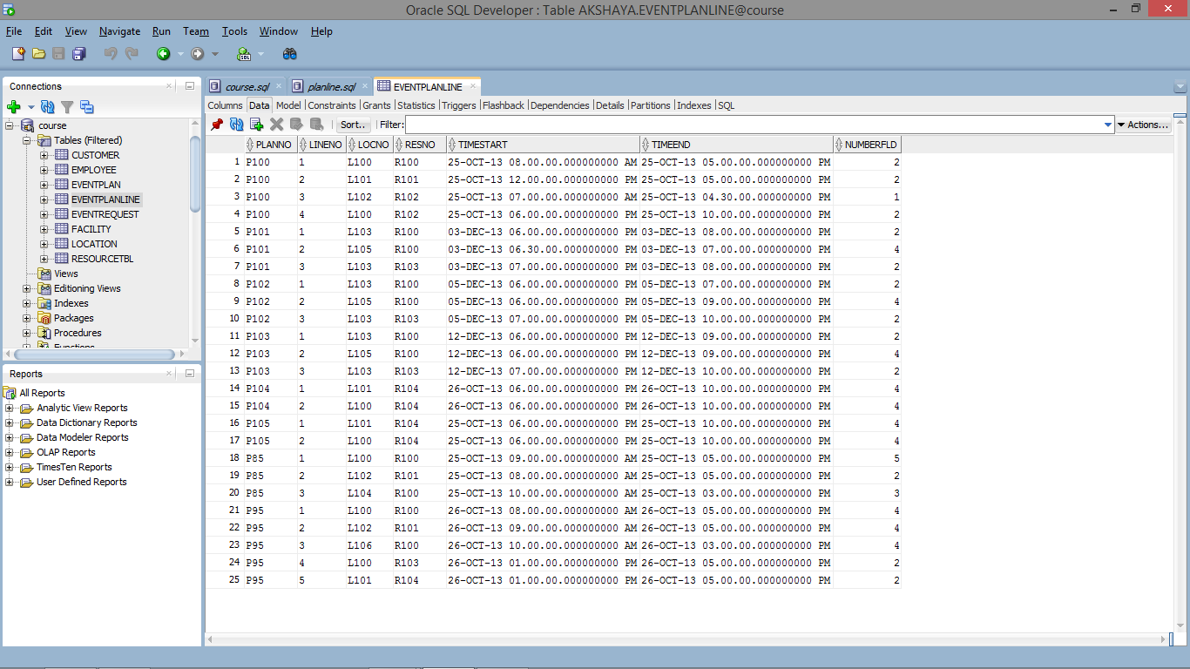

CREATE TABLE EventPlanLine (

planNo CHAR(8) NOT NULL,

lineNo VARCHAR2(8) NOT NULL,

locNo VARCHAR2(8) NOT NULL,

resNo CHAR(8) NOT NULL,

timeStart TIMESTAMP NOT NULL,

timeEnd TIMESTAMP NOT NULL,

numberFLD INTEGER NOT NULL,

CONSTRAINT PK_EventPlanLine PRIMARY KEY (planNo, lineNo),

CONSTRAINT FK_EventPlan FOREIGN KEY (planNo) REFERENCES EventPlan (planNo),

CONSTRAINT FK_Location FOREIGN KEY (locNo) REFERENCES Location (locNo),

CONSTRAINT FK_ResourceTbl FOREIGN KEY (resNo) REFERENCES ResourceTbl (resNo)

);

Insert into EVENTPLANLINE (PLANNO,LINENO,TIMESTART,TIMEEND,NUMBERFLD,LOCNO,RESNO) values ('P100',1, to_date('25-OCT-13 8:00:00','DD-MON-RR HH24:MI:SS'), to_date('25-OCT-13 17:00:00','DD-MON-RR HH24:MI:SS'),2,'L100','R100');  
 Insert into EVENTPLANLINE (PLANNO,LINENO,TIMESTART,TIMEEND,NUMBERFLD,LOCNO,RESNO) values ('P100',2, to_date('25-OCT-13 12:00:00','DD-MON-RR HH24:MI:SS'),to_date('25-OCT-13 17:00:00','DD-MON-RR HH24:MI:SS'), 2,'L101','R101');  
 Insert into EVENTPLANLINE (PLANNO,LINENO,TIMESTART,TIMEEND,NUMBERFLD,LOCNO,RESNO) values ('P100',3, to_date('25-OCT-13 7:00:00','DD-MON-RR HH24:MI:SS'), to_date('25-OCT-13 16:30:00','DD-MON-RR HH24:MI:SS'), 1,'L102','R102');  
 Insert into EVENTPLANLINE (PLANNO,LINENO,TIMESTART,TIMEEND,NUMBERFLD,LOCNO,RESNO) values ('P100',4, to_date('25-OCT-13 18:00:00','DD-MON-RR HH24:MI:SS'),to_date('25-OCT-13 22:00:00','DD-MON-RR HH24:MI:SS'),2,'L100','R102');  
 Insert into EVENTPLANLINE (PLANNO,LINENO,TIMESTART,TIMEEND,NUMBERFLD,LOCNO,RESNO) values ('P101',1, to_date('3-DEC-13 18:00:00','DD-MON-RR HH24:MI:SS'),to_date('3-DEC-13 20:00:00','DD-MON-RR HH24:MI:SS'),2,'L103','R100');  
 Insert into EVENTPLANLINE (PLANNO,LINENO,TIMESTART,TIMEEND,NUMBERFLD,LOCNO,RESNO) values ('P101',2, to_date('3-DEC-13 18:30:00','DD-MON-RR HH24:MI:SS'),to_date('3-DEC-13 19:00:00','DD-MON-RR HH24:MI:SS'),4,'L105','R100');  
 Insert into EVENTPLANLINE (PLANNO,LINENO,TIMESTART,TIMEEND,NUMBERFLD,LOCNO,RESNO) values ('P101',3, to_date('3-DEC-13 19:00:00','DD-MON-RR HH24:MI:SS'),to_date('3-DEC-13 20:00:00','DD-MON-RR HH24:MI:SS'),2,'L103','R103');  
 Insert into EVENTPLANLINE (PLANNO,LINENO,TIMESTART,TIMEEND,NUMBERFLD,LOCNO,RESNO) values ('P102',1, to_date('5-DEC-13 18:00:00','DD-MON-RR HH24:MI:SS'),to_date('5-DEC-13 19:00:00','DD-MON-RR HH24:MI:SS'),2,'L103','R100');  
 Insert into EVENTPLANLINE (PLANNO,LINENO,TIMESTART,TIMEEND,NUMBERFLD,LOCNO,RESNO) values ('P102',2, to_date('5-DEC-13 18:00:00','DD-MON-RR HH24:MI:SS'),to_date('5-DEC-13 21:00:00','DD-MON-RR HH24:MI:SS'),4,'L105','R100');  
 Insert into EVENTPLANLINE (PLANNO,LINENO,TIMESTART,TIMEEND,NUMBERFLD,LOCNO,RESNO) values ('P102',3, to_date('5-DEC-13 19:00:00','DD-MON-RR HH24:MI:SS'),to_date('5-DEC-13 22:00:00','DD-MON-RR HH24:MI:SS'),2,'L103','R103');  
 Insert into EVENTPLANLINE (PLANNO,LINENO,TIMESTART,TIMEEND,NUMBERFLD,LOCNO,RESNO) values ('P103',1, to_date('12-DEC-13 18:00:00','DD-MON-RR HH24:MI:SS'),to_date('12-DEC-13 21:00:00','DD-MON-RR HH24:MI:SS'),2,'L103','R100');  
 Insert into EVENTPLANLINE (PLANNO,LINENO,TIMESTART,TIMEEND,NUMBERFLD,LOCNO,RESNO) values ('P103',2, to_date('12-DEC-13 18:00:00','DD-MON-RR HH24:MI:SS'),to_date('12-DEC-13 21:00:00','DD-MON-RR HH24:MI:SS'),4,'L105','R100');  
 Insert into EVENTPLANLINE (PLANNO,LINENO,TIMESTART,TIMEEND,NUMBERFLD,LOCNO,RESNO) values ('P103',3, to_date('12-DEC-13 19:00:00','DD-MON-RR HH24:MI:SS'),to_date('12-DEC-13 22:00:00','DD-MON-RR HH24:MI:SS'),2,'L103','R103');  
 Insert into EVENTPLANLINE (PLANNO,LINENO,TIMESTART,TIMEEND,NUMBERFLD,LOCNO,RESNO) values ('P104',1, to_date('26-OCT-13 18:00:00','DD-MON-RR HH24:MI:SS'),to_date('26-OCT-13 22:00:00','DD-MON-RR HH24:MI:SS'),4,'L101','R104');  
 Insert into EVENTPLANLINE (PLANNO,LINENO,TIMESTART,TIMEEND,NUMBERFLD,LOCNO,RESNO) values ('P104',2, to_date('26-OCT-13 18:00:00','DD-MON-RR HH24:MI:SS'),to_date('26-OCT-13 22:00:00','DD-MON-RR HH24:MI:SS'),4,'L100','R104');  
 Insert into EVENTPLANLINE (PLANNO,LINENO,TIMESTART,TIMEEND,NUMBERFLD,LOCNO,RESNO) values ('P105',1, to_date('25-OCT-13 18:00:00','DD-MON-RR HH24:MI:SS'),to_date('25-OCT-13 22:00:00','DD-MON-RR HH24:MI:SS'),4,'L101','R104');  
 Insert into EVENTPLANLINE (PLANNO,LINENO,TIMESTART,TIMEEND,NUMBERFLD,LOCNO,RESNO) values ('P105',2, to_date('25-OCT-13 18:00:00','DD-MON-RR HH24:MI:SS'),to_date('25-OCT-13 22:00:00','DD-MON-RR HH24:MI:SS'),4,'L100','R104');  
 Insert into EVENTPLANLINE (PLANNO,LINENO,TIMESTART,TIMEEND,NUMBERFLD,LOCNO,RESNO) values ('P199',1, to_date('10-DEC-13 8:00:00','DD-MON-RR HH24:MI:SS'), to_date('10-DEC-13 12:00:00','DD-MON-RR HH24:MI:SS'),1,'L100','R100');  
 Insert into EVENTPLANLINE (PLANNO,LINENO,TIMESTART,TIMEEND,NUMBERFLD,LOCNO,RESNO) values ('P349',1, to_date('12-DEC-13 12:00:00','DD-MON-RR HH24:MI:SS'),to_date('12-DEC-13 15:30:00','DD-MON-RR HH24:MI:SS'),1,'L103','R100');  
 Insert into EVENTPLANLINE (PLANNO,LINENO,TIMESTART,TIMEEND,NUMBERFLD,LOCNO,RESNO) values ('P85',1, to_date('25-OCT-13 9:00:00','DD-MON-RR HH24:MI:SS'), to_date('25-OCT-13 17:00:00','DD-MON-RR HH24:MI:SS'),5,'L100','R100');  
 Insert into EVENTPLANLINE (PLANNO,LINENO,TIMESTART,TIMEEND,NUMBERFLD,LOCNO,RESNO) values ('P85',2, to_date('25-OCT-13 8:00:00','DD-MON-RR HH24:MI:SS'), to_date('25-OCT-13 17:00:00','DD-MON-RR HH24:MI:SS'),2,'L102','R101');  
 Insert into EVENTPLANLINE (PLANNO,LINENO,TIMESTART,TIMEEND,NUMBERFLD,LOCNO,RESNO) values ('P85',3, to_date('25-OCT-13 10:00:00','DD-MON-RR HH24:MI:SS'), to_date('25-OCT-13 15:00:00','DD-MON-RR HH24:MI:SS'),3,'L104','R100');  
 Insert into EVENTPLANLINE (PLANNO,LINENO,TIMESTART,TIMEEND,NUMBERFLD,LOCNO,RESNO) values ('P95',1, to_date('26-OCT-13 8:00:00','DD-MON-RR HH24:MI:SS'), to_date('26-OCT-13 17:00:00','DD-MON-RR HH24:MI:SS'),4,'L100','R100');  
 Insert into EVENTPLANLINE (PLANNO,LINENO,TIMESTART,TIMEEND,NUMBERFLD,LOCNO,RESNO) values ('P95',2, to_date('26-OCT-13 9:00:00','DD-MON-RR HH24:MI:SS'), to_date('26-OCT-13 17:00:00','DD-MON-RR HH24:MI:SS'),4,'L102','R101');  
 Insert into EVENTPLANLINE (PLANNO,LINENO,TIMESTART,TIMEEND,NUMBERFLD,LOCNO,RESNO) values ('P95',3, to_date('26-OCT-13 10:00:00','DD-MON-RR HH24:MI:SS'), to_date('26-OCT-13 15:00:00','DD-MON-RR HH24:MI:SS'),4,'L106','R100');  
 Insert into EVENTPLANLINE (PLANNO,LINENO,TIMESTART,TIMEEND,NUMBERFLD,LOCNO,RESNO) values ('P95',4, to_date('26-OCT-13 13:00:00','DD-MON-RR HH24:MI:SS'), to_date('26-OCT-13 17:00:00','DD-MON-RR HH24:MI:SS'),2,'L100','R103');  
 Insert into EVENTPLANLINE (PLANNO,LINENO,TIMESTART,TIMEEND,NUMBERFLD,LOCNO,RESNO) values ('P95',5, to_date('26-OCT-13 13:00:00','DD-MON-RR HH24:MI:SS'), to_date('26-OCT-13 17:00:00','DD-MON-RR HH24:MI:SS'),2,'L101','R104');